Question 3

To answer this question, we use the idea of the annuity formula to discount all the future cashflow and calculate the PV of all future cashflow.

The table below is the binomial model of gold:

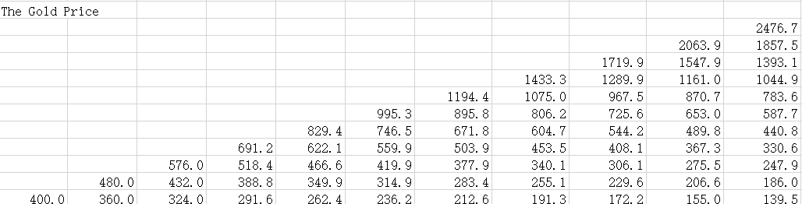

Given a gold price, the cashflow will be price – extraction cost. When the cashflow is negative, the gold will not be extracted from the Simplico gold mine and the cashflow is 0. Therefore the binomial model of cashflow is：

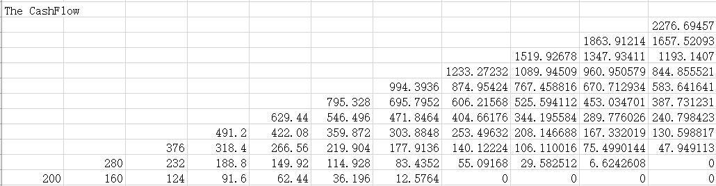

In each time period but $t_{0}$, there is more than one possible gold price. Therefore, we need to calculate the expected cash flow of each time period. The binomial model of the possibility of each gold price is:

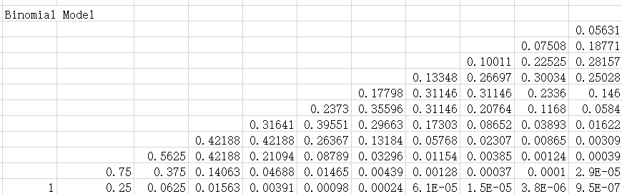

With the table above, we could then calculate the expected value of cashflow at each time period:



And we could discount the expected value of cashflow by the risk-free rate $R$



Summing them together, the PV of all future cashflow is 3506.77. Multiplying the PV by 10K, the max extraction rate of each time period, the price of lease is 35067782.39 or 35.1M, which is larger than 24.1M. However, it can still prove that 24.1M is a reasonable value of the lease.